 CTE STEM Two Year Plan: Program ______________ 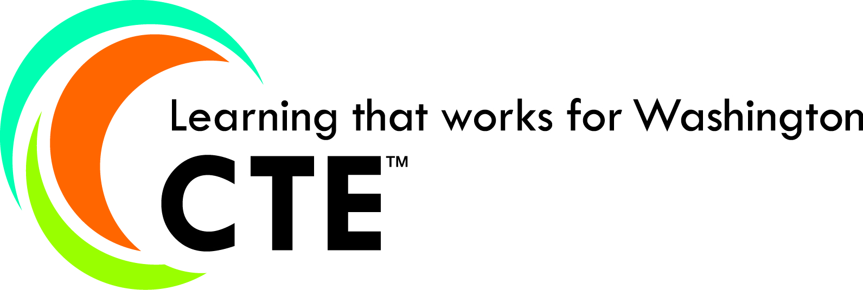
Goal area | Instructional Practices:  What are we going to do to get students learning to high standards? |  |  | People Involved |  | Schedule of Activities |  | Resources Needed  -professional development  -trainers  -district support | Evidence of Implementation.  What are teachers doing? | Evidence of Impact:  What are students’ doing?
CURRICULUM INSTRUCTION

HSPE and EOC alignment

CAREER COMPONENT (Bridges, WOIS)

LEADERSHIP

INDUSTRY AND POST SECONDARY CONNECTIONS

PROGRAM MARKETING

ADVISORY COMMITTEE

Program Advisory Chair |  |  |  |  | Date
Career/Technical Director |  |  |  |  | Date

